**TITLE: Macros**

**PROBLEM STATEMENT:**

Design suitable data structures and implement macro definition and macro expansion processing for a sample macro with positional and keyword parameters.

**THEORY:**

* Macros: Macro is a unit of specification of program generation through expansion. It is single line abbreviation for group of instructions Typically MACRO is defined at start of program or at end of program.
* Actual Parameters: The arguments that are passed in a function call are called actual arguments. These arguments are defined in the calling function. These are the variables or expressions referenced in the parameter list of a subprogram call. There is no need to specify datatype in actual parameter.
* Formal Parameters: When a function is called, the values (expressions) that are passed in the function call are called the arguments or actual parameters. The parameter used in function definition statement which contain data type on its time of declaration is called formal parameter.

**PROGRAM:**

#include<stdio.h>

#include<string.h>

#include<stdlib.h>

char line[80],t1[10],t2[20],t3[10],FPN[20],APN[20],mname[10]; int count , v1,v2,v3,v4;

FILE *ifp;

int main()

{

int index=1;

ifp= fopen("intmacro.txt","r"); while(!feof(ifp))

{

fgets(line,20,ifp);

count = sscanf(line,"%s%s%s",t1,t2,t3); if(strcmp("MACRO",t1)==0)

{

strcpy(mname,t2); printf("\n macro name table"); printf("\n----------------\n"); printf("\n%s",mname);

}

if(strcmp(mname,t2)==0)

{

strcpy(FPN,t3);

printf("\n\n\n**FORMAL PARAMETER NAME TABLE**");

printf("\n-------------------------------:\n");

printf("\nINDEX\t\t:FORMAL PARAMETER NAME"); printf("\n%d\t:%s",index,FPN);

}

if(strcmp(mname,t1)==0)

{

strcpy(APN,t2);

printf("\n\n\n**ACTUAL PARAMETER NAME TABLE**");

printf("\n----------------------:\n");

printf("\nINDEX\t\t:ACTUAL PARAMETER NAME");

printf("\n%d\t:%s",index,APN);

}

}

**Intmacro.txt input file:**

MACRO ADDS X

ADD AREG BREG MEND

START 100

MOVER AREG CREG

ADDS X1

SUB AREG CREG

END

**OUTPUT:**

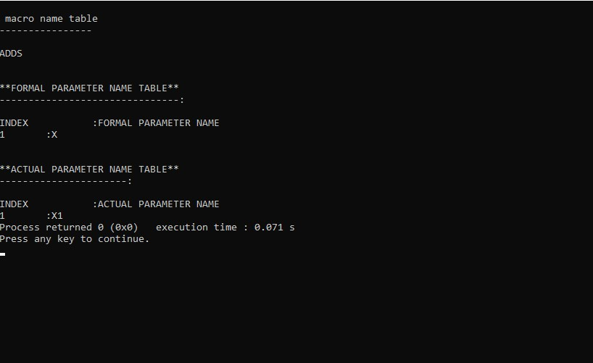

**CONCLUSION:**

Hence, we have successfully learnt the implementation and the theory of macros .